My Art Show Schedule 2020-2021 Season (committed)
OCTOBER 10-11 VERO BEACH FALL ART & CRAFT

Vero Beach, FL Home & Remodel Show and Arts & Crafts Expo

Fall Edition October 10-11, 2020

A Unique Blend of a Home & Remodel Show, Arts & Crafts Expo, Retail Sales Plus Entertainment for the Entire Family...

Location: Vero Beach Fair Grounds 7955 58th Ave in Vero Beach!

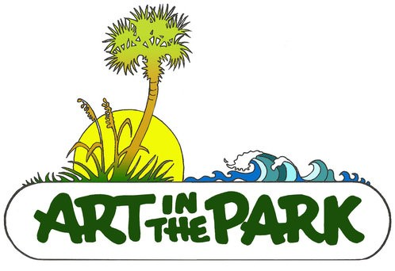

40TH ANNUAL
ART IN THE PARK FINE ARTS & CRAFTS SHOW

Various Sunday’s from 10am - 4pm

2020 Dates:
Sunday, October 25, 2020
Sunday, November 8, 2020
Sunday, November 22, 2020
Sunday, December 13 2020
2021 Dates:
Sunday, January10, 2021
Sunday, January 31, 2021
Sunday, February 14, 2021
Sunday, February 28, 2021
Sunday March 28th, 2021
Sunday, April 11, 2021
Location: Humiston Park Ocean Side, 3000 Ocean Dr., Vero Beach Florida

32ND ANNUAL
ART BY THE SEA FINE ARTS & CRAFTS SHOW

JANUARY 2021 (DATES TBD) 3 day event Fri-Sun

Location:

Vero Beach Museum of Art, 3001 Riverside Park Dr, Vero Beach Florida

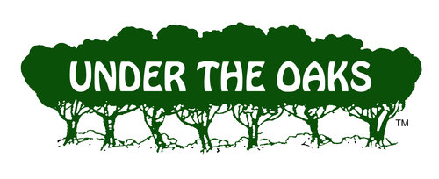

70TH ANNUAL
UNDER THE OAKS
FINE ARTS & CRAFTS SHOW
OUR LARGEST FUND RAISER
MARCH 12, 13, 14, 2021

Location:

Riverside park, 3200 Riverside Park Drive, Vero Beach Florida

